Experiment 1
Library Management System
Aim : To develop a Library Management System website that helps students and librarians manage books and study materials easily. It allows users to search books, borrow and return them, check fines, view borrowing history, and download year- and semester-wise study materials. The admin can manage book records, student details, issued books, returns, and fines.
Procedure :
- First, design a user-friendly website with separate login pages for the librarian admin and students.
- Create a registration and login system for students to access their accounts.
- Develop the admin dashboard to add, update, and delete books and manage student details.
- Implement the book issuing and returning process by recording issue dates and expected return dates.
- Add a fine calculation feature for books returned after the due date.
- Provide a search option for students to find books and view their availability.
- Create a borrowing history page where students can check their issued books, issue dates, and expected return dates.
- Add a study material section where the admin can upload materials according to the year and semester, and students can search and download them.
- Develop the student profile page and a contact form for sending queries.
- Finally, test all the features to ensure that book records, student accounts, borrowing details, and fine calculations work correctly.
Sample Code :

<!DOCTYPE html>
<html>
<head>
<title>Library Management System</title>
</head>
<body>
<h1>Library Management System</h1>

<h2>Student Login</h2>
<input type="text" placeholder="Enter Name">
<input type="password" placeholder="Password">
<button>Login</button>

<h2>Search Book</h2>
<input type="text" id="book" placeholder="Enter Book Name">
<button onclick="searchBook()">Search</button>
<p id="result"></p>

<h2>Admin - Add Book</h2>
<input type="text" id="newBook" placeholder="Book Name">
<button onclick="addBook()">Add Book</button>
<ul id="list">
<li>Python Programming</li>
<li>Java Programming</li>
</ul>

<h2>Borrow History</h2>
<p>Issue Date: 10-10-2026</p>
<p>Expected Return Date: 20-10-2026</p>
<p>Fine: ₹0</p>

<h2>Study Materials</h2>
<p>Year: 2 | Semester: 1</p>
<a href="notes.pdf" download>Download Notes</a>

<h2>Contact Us</h2>
<input type="email" placeholder="Enter Email">
<textarea placeholder="Your Message"></textarea>
<button>Submit</button>

<script>
function searchBook() {
let book = document.getElementById("book").value;
document.getElementById("result").innerHTML =
"Search result: " + book;
}

function addBook() {
let book = document.getElementById("newBook").value;
if (book !== "") {
let li = document.createElement("li");
li.textContent = book;
document.getElementById("list").appendChild(li);
}
}
</script>
</body>
</html>

Output :
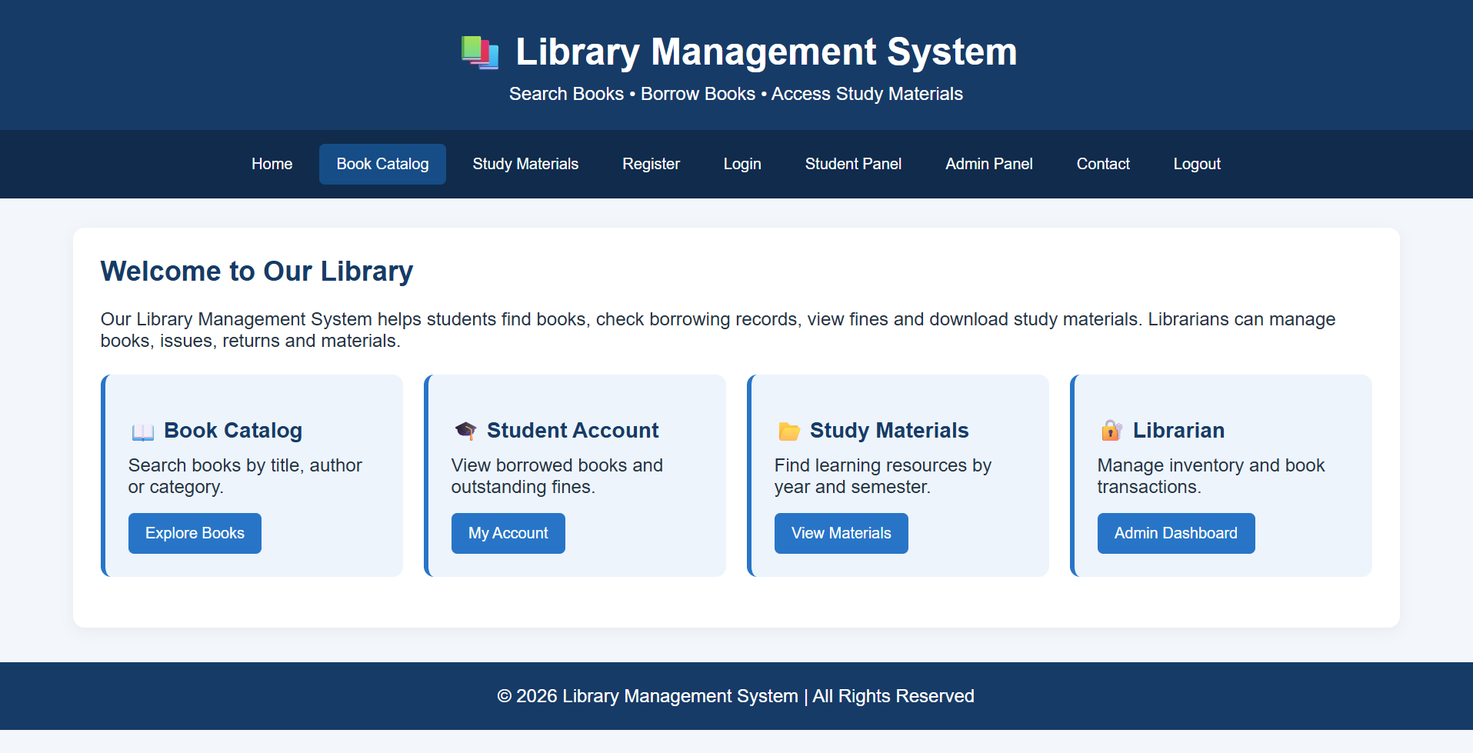

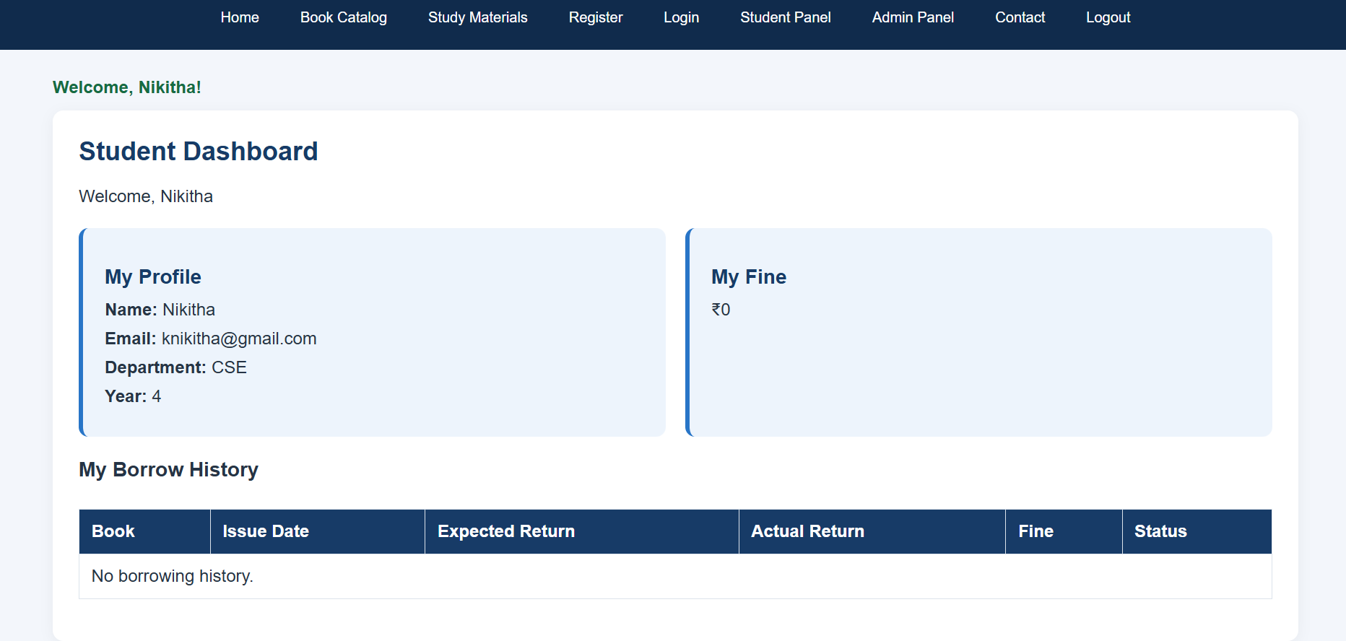

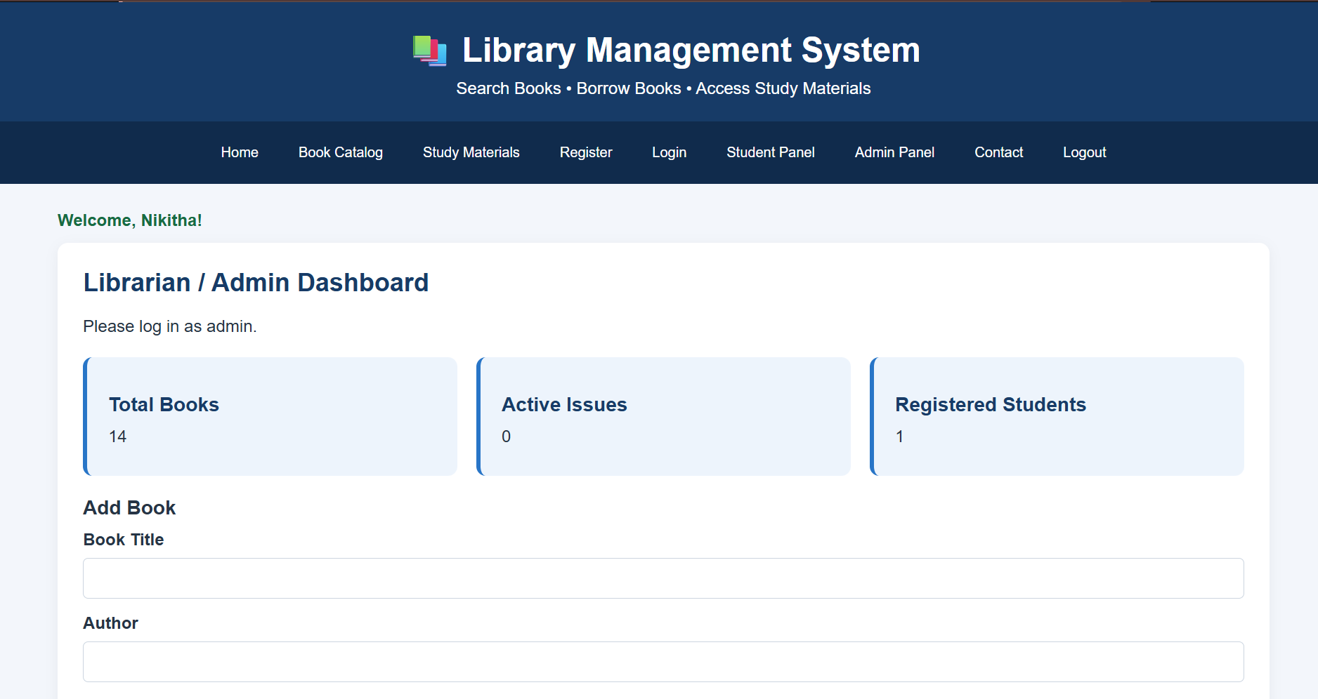

Result :
The Library Management System website was designed to simplify library activities for students and librarians. It helps the admin manage books, issue and return records, and fines, while students can search for books, check their borrowing history, view fines, and download study materials. Thus, the system reduces manual work and makes library management easier, faster, and more organized.

